2019＆2020小兒口試
1. Radiation therapy 會對小兒造成許多toxicity 和sequalae，請問有哪些方式可以降低上述的狀況呢?
- 如果可以，直接省去放射治療，如low grade astrocytoma單純接受手術
- 小於三歲的小孩盡量以systemic treatment (ex. HDCT)為主，將RTdelay至三歲以後
- 加強模具固定，影像導引讓margin可以比較小，減少正常組織照射
- 使用Proton therapy，尤其是CSI !! (老師最想聽到的答案，老師表示：兒癌病人都應該幫他找社工，籌錢去做proton)
- 減少照射範圍（如在standard risk MB照射Involved field而非posterior fossa）
- 減少劑量（如在standard risk MB照射由36Gy降低到23.4Gy）
- 使用小fraction size的RT ( ex. Germinoma 可以使用1.5 Gy per fraction),
2. 哪些pediatric CNS tumor一定要做CSI (在沒有seeding 的狀況下)?
- Embryonal tumors: medulloblastoma, embryonal tumors with multilayer, ATRT
- Nongerminomatous germ cell tumors
- Pineoblastoma
3. 哪些pediatric CNS tumor開完刀之後可以不用照RT?
- Low grade glioma
- Pituitary tumor
- Craniopharyngioma, GTR
- Spine low grade ependymoma
- Choroid plexus tumor
4. RT 最大的副作用是什麼?
neurocognitive function decline, 生長遲緩，結果老師都說不是，是local recurrence (這…..)，他只是想提醒我們小兒的RT照射範圍一定要按照guideline，該1.5cm 就1.5 cm，不要想說都只加0.5 cm
5. 貴院的TBI的技術? 劑量?
- Ans. 有AP/PA的方式 (缺點: 要加lung shielding) or bilateral (缺點:要加tissue compensator)，劑量就看各種protocol 而定(常見; 1.5 Gy BID*4 天 = total 12 Gy)
6. TBI 要告知病人有哪些副作用或toxicity ?
- (1) Acute toxicity: alopecia, hematological toxicity, mucositis, diarrhea
- (2) Late toxicity: cataract, pulmonary fibrosis, infertility, secondary malignancy (老師強調cataract 和secondary malignancy 一定要告知!!)
許哲瑜 (Pediatric)
- Ewing, rhabdo, Wilms tumor, neuroblastoma 好發年紀
Rhabdo: Incidence peaks at 2-6 years old (embryonal histology) and 10-14(alveolar histology)
Ewing sarcoma: Median age 14y/o
Wilms tumor: 3-4y/o
Neuroblastoma: 18M
- Neuroblastoma/Wilms tumor怎麼分?
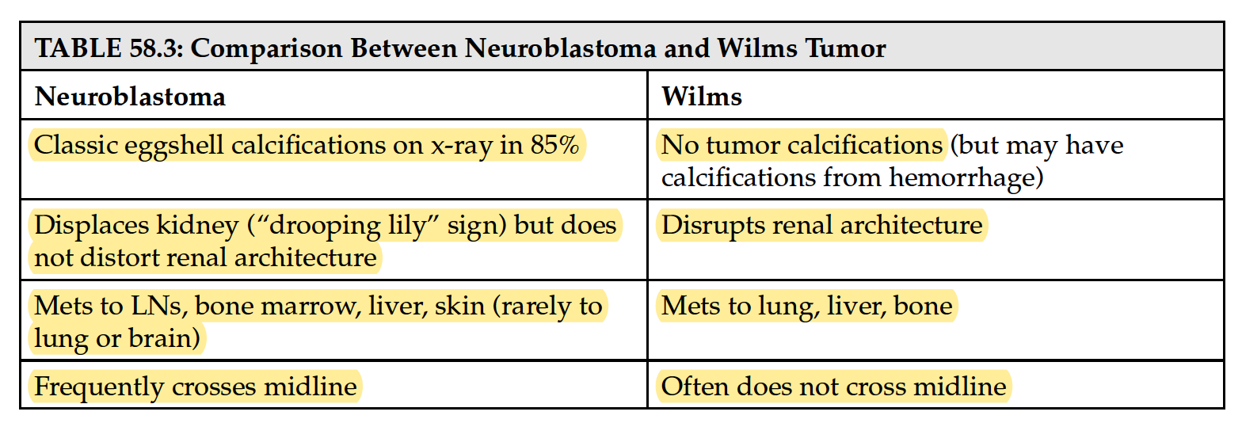
- Neuroblastoma,
  - 好發位置? A: 出現在交感神經系統的位置，最常見是腎上腺
  - INSS stage? 4S定義?
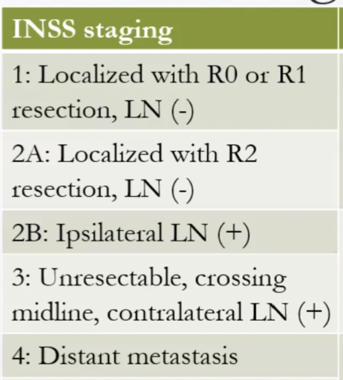
Stage 4S: The original tumor is located only where it started (as in Stages
1, 2A, or 2B), and it has spread only to the skin, liver, and/or bone
marrow, in infants younger than 1 year. The spread to the bone marrow is minimal; usually <10% of cells examined show cancer.
Cf: INRG MS: <18m with metastases only to skin, liver, bone marrow (SLBM)

  - 如何分risk? 每個risk如何治療? 什麼時候照RT?
首先要看 INSS staging system, N-myc, histology, ploidy , 年紀決定risk
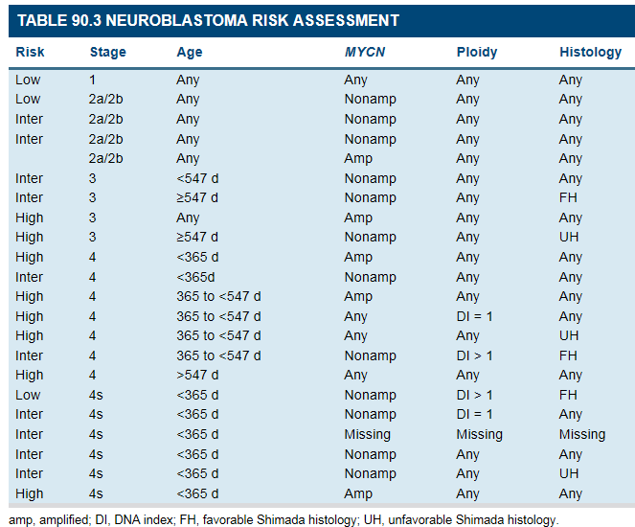

Low risk: 若GTR🡪 觀察; STR, unresectable, recurrence🡪 Chemotherapy 6-12wk
Intermediate risk: GTR+ lymphadenectomy+ chemotherapy 12-24wks
High risk: induction chemotherapy 5 cycles🡪 Surgery🡪 High dose chemotherapy with stem cell rescue🡪 RT🡪consolidation therapy with immunotherapy (dinutuximab and cytotokine) & isotretinion

  - RT 的角色
- Low risk : 針對4S的病人若病人因為tumor 太大而有respiratory distress, 可給予21 Gy/ 1.5 Gy per fraction 緩解, 4.5 Gy/1.5 Gy per fraction for hepatomegaly mets
- Intermediate risk : 針對化療後還有症狀或是殘留的腫瘤給予照射
- High risk: 21.6Gy/1.8 per fraction to residual primary and metastatic site after HDCT, whether boost (14.4 Gy) is controversial
  - RT範圍?
post CT volume, tumor bed, and residual tumor with a 1- to 1.5-cm margin
  - 照多少? 照RT的時候Spine要壓多少
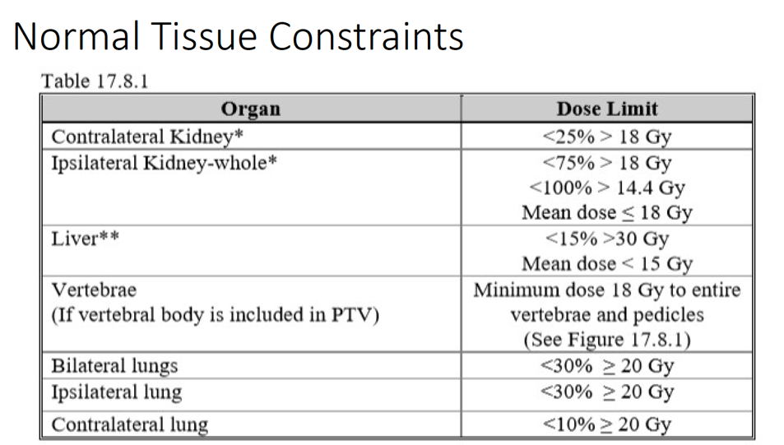
- Wilms tumor
  - stage怎麼分, 如何分risk?
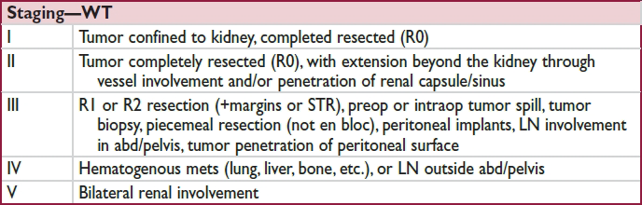
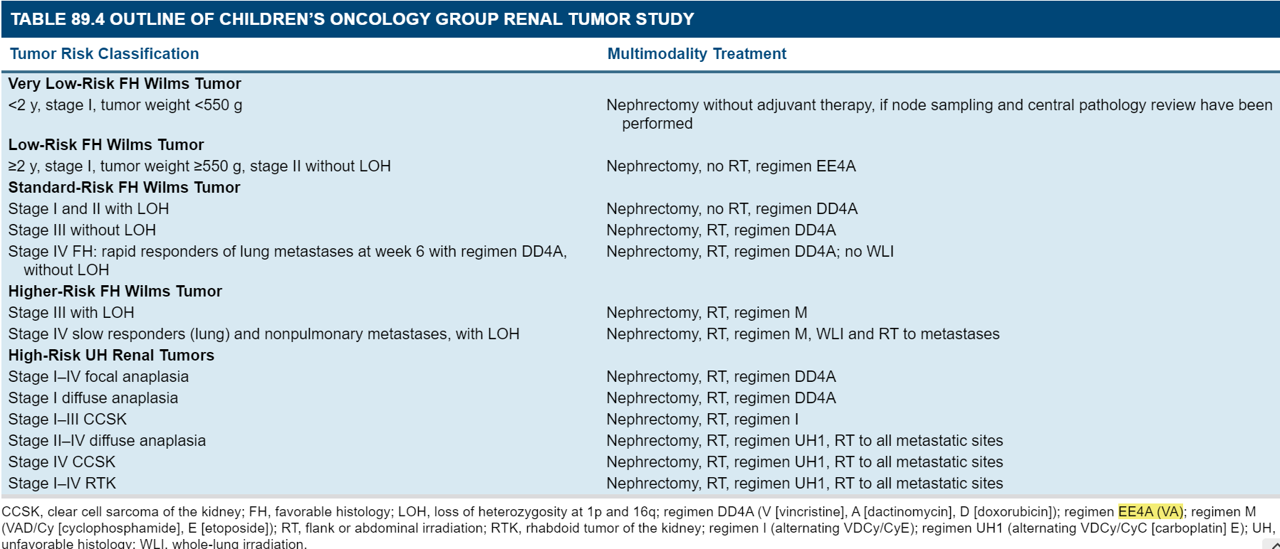
  - 什麼時候照flank RT, RT要注意什麼？
範圍：術前腫瘤＋kidney+1cm+整個vertebral body若有碰到VB
小心對側kidney, 有擦到的話field可以退一點
  - WAI什麼時候要做, 範圍, WAI要注意什麼?
時機：Diffuse tumor spillage, preoperative or intraperitoneal tumor rupture, peritoneal tumor seeding, or hemorrhagic or cytology positive ascites
範圍：上界：diaphragm 上1cm; 下界：obturator foramen
WART要擋femoral bone
When WAI dose is >10 Gy, renal shielding is required to limit the dose to the remaining kidney to <14.4 Gy. Gross residual disease after surgery should receive a boost of 10 Gy. WAI dose is not to exceed 10 Gy in infants ≤12 months.

